VPC CHALLENGE
Use Case: Setting up Transit Gateway and VPC Endpoints for a Multi-VPC
Architecture
Scenario:
A large organization is migrating its on-premises infrastructure to the AWS
cloud.
The organization's architecture involves multiple VPCs for different
departments and applications, each requiring secure communication with
centralized services and external resources.
The IT team needs to design and implement a scalable and efficient network
architecture to accommodate the organization's growth and ensure robust
connectivity between VPCs and external services.
Objectives:
Design and deploy a scalable network architecture using AWS Transit
Gateway to simplify network connectivity between multiple VPCs.
Configure VPC endpoints to securely access AWS services without
internet gateways or NAT gateways, ensuring data privacy and
minimizing exposure to external threats.
- Set up a VPC Transit Gateway.
- Create multiple vpc in the region with public subnets and total
Configuration.
- Created 4 vpc’s with names VPC1/VPC2/VPC4/VPC4, and added Internet
gateway, created subnets for each vpc and added to the Route Table,
Created EC2 instance for each vpc and added security groups also to it
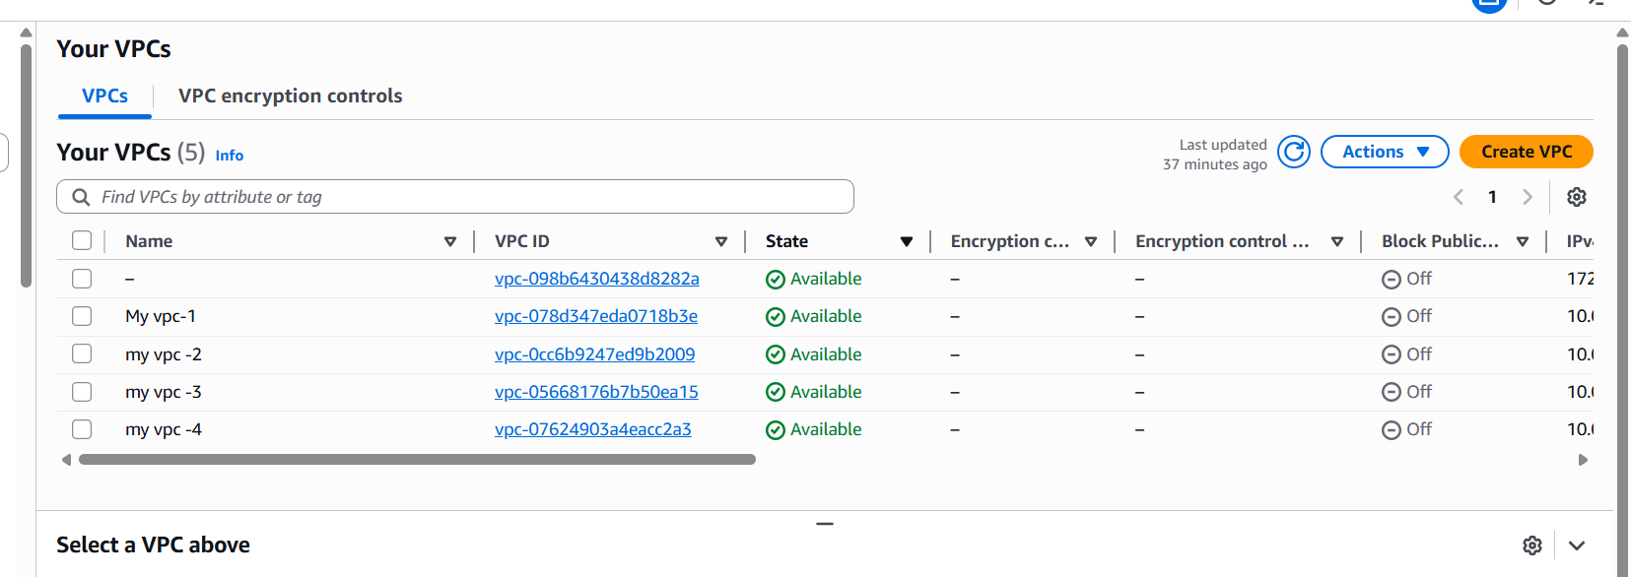
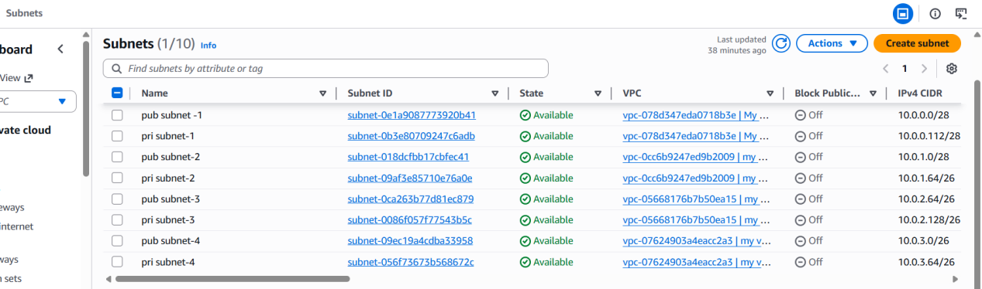
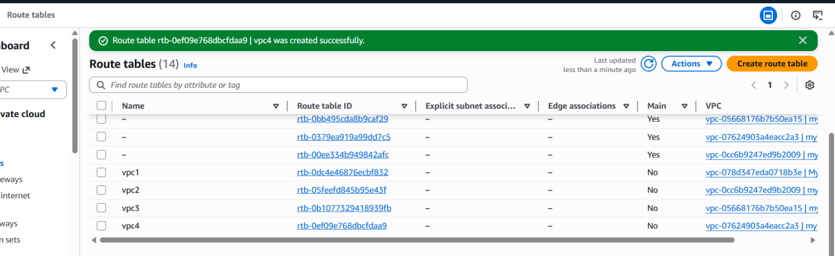
After completing route tables creating internet gateway was created for every vpc that vpc has attached or detached see once go to subnet associations created successfully after created then we want to give routes connection to route tables in with igw
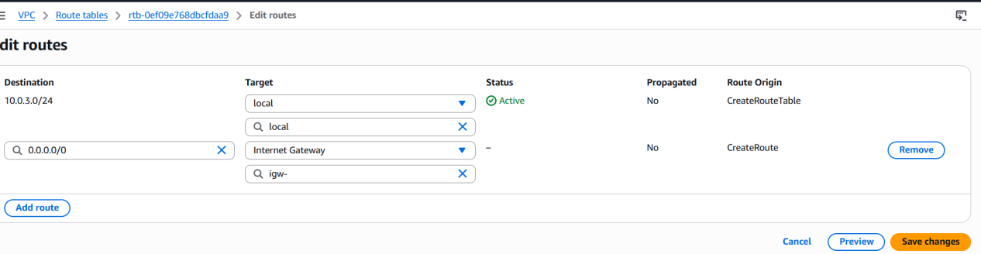
Create transit gateways
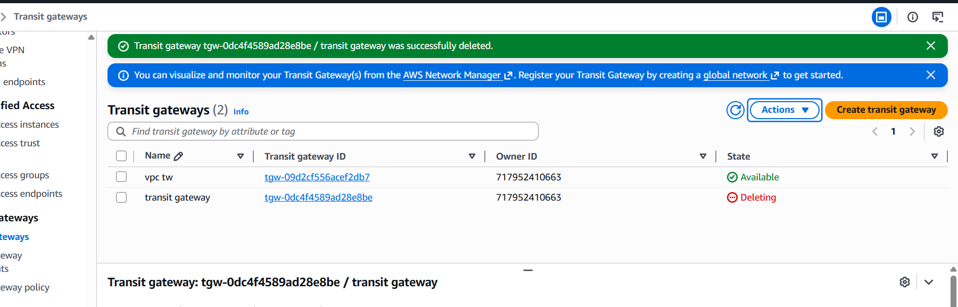
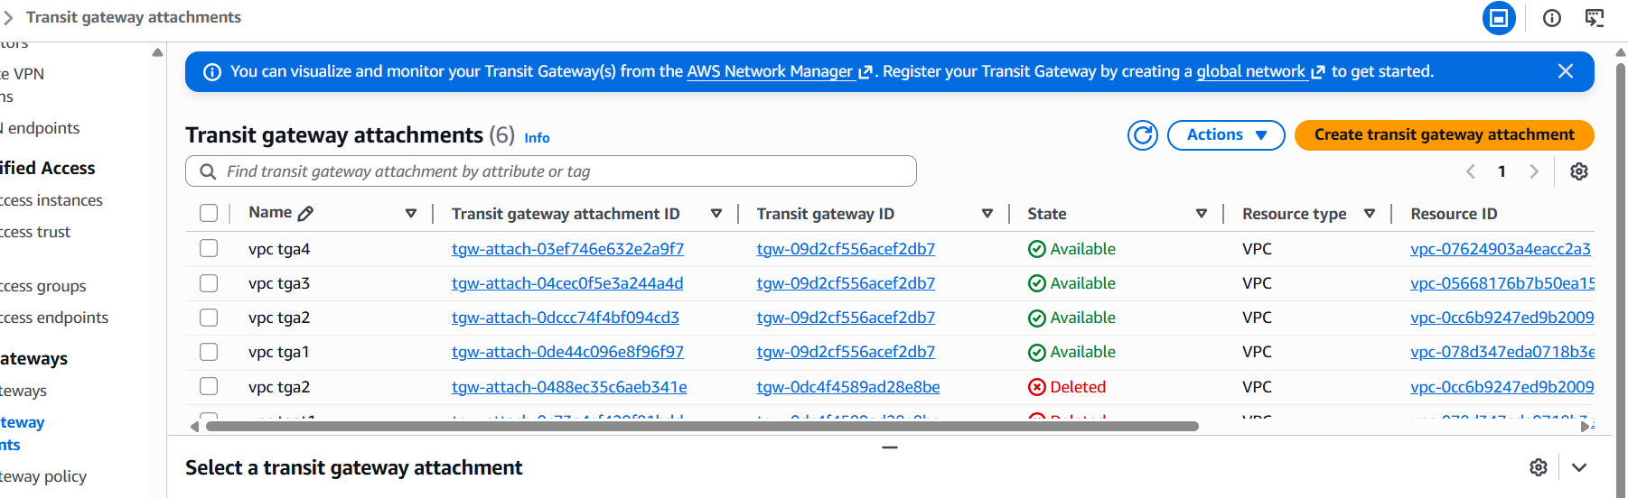
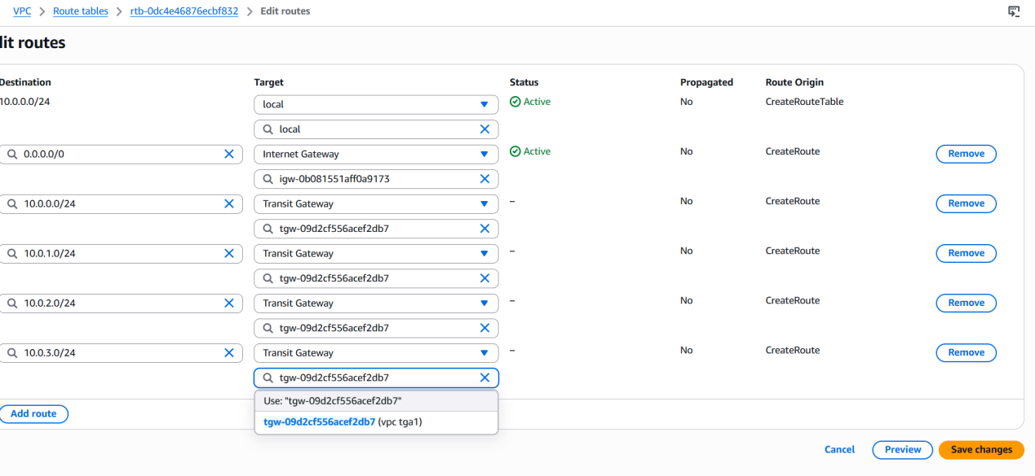
Now I created every transit gateway attachements different different vpcs with different transit attachements after completed attachements I want to check the connections are associated or not.
check below transit gateway route tables
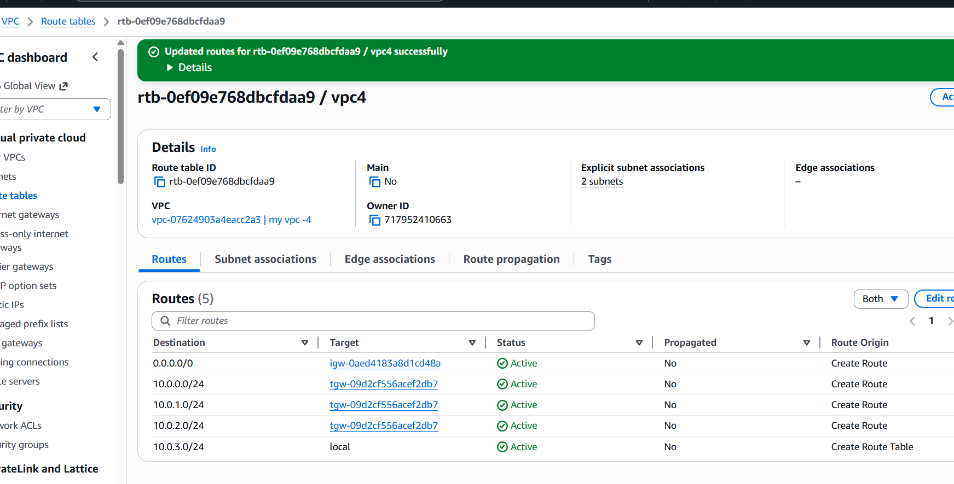
Go to route tables and add any vpc have to connect all extra three cidr numbers with transit gateway id shown in below
I created transit gateway to given vpcs and now I created instances
four instances I am showing only 2
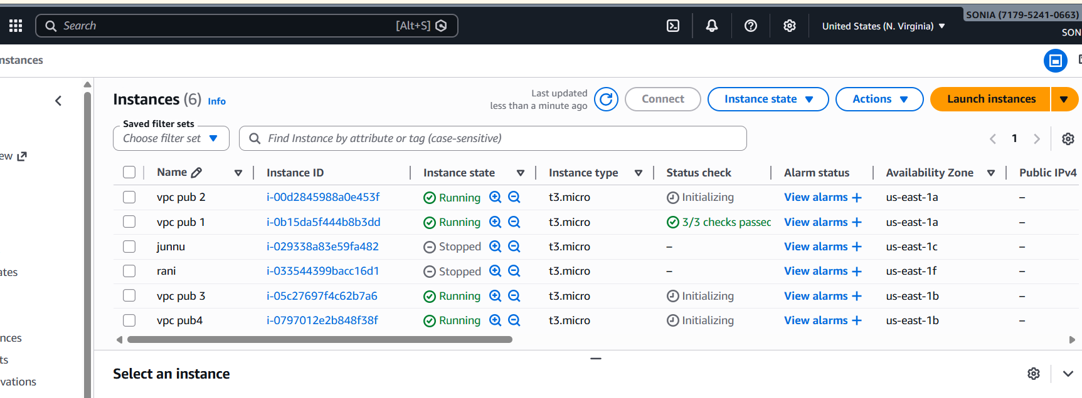
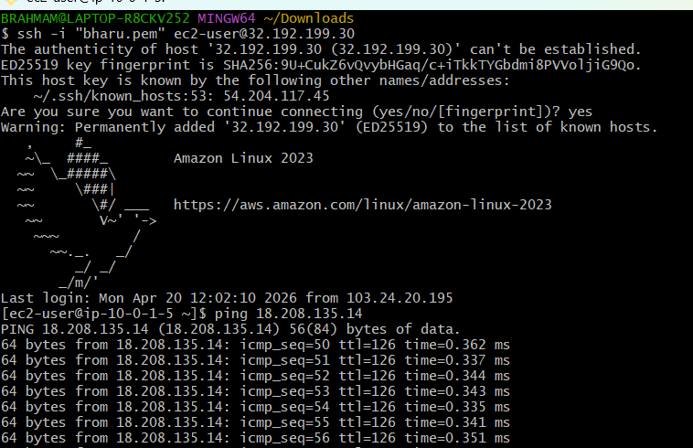
Create a endpoint
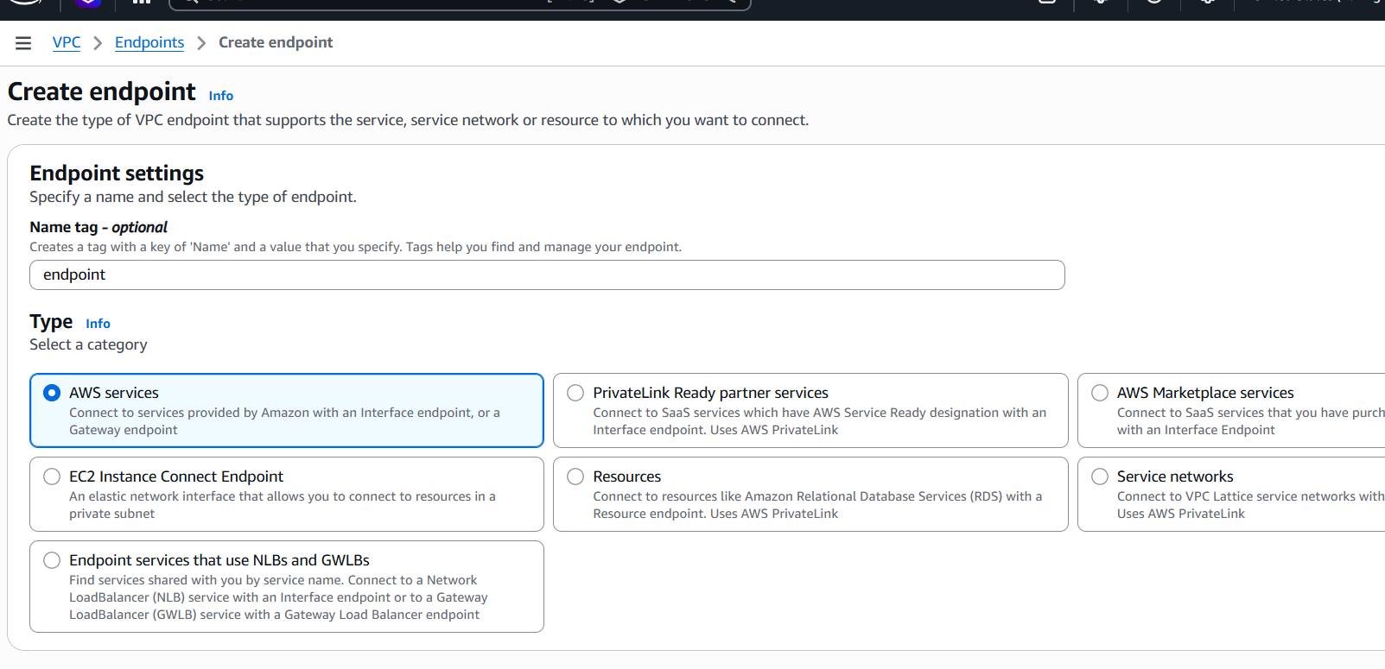
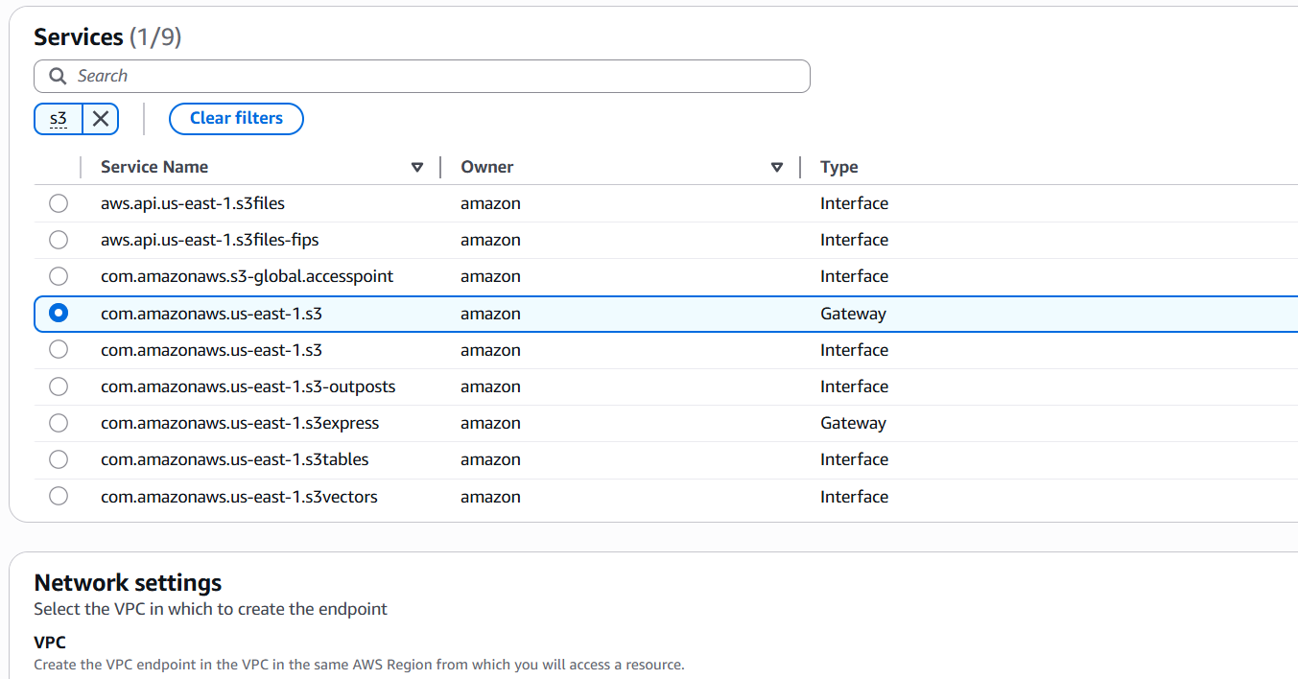
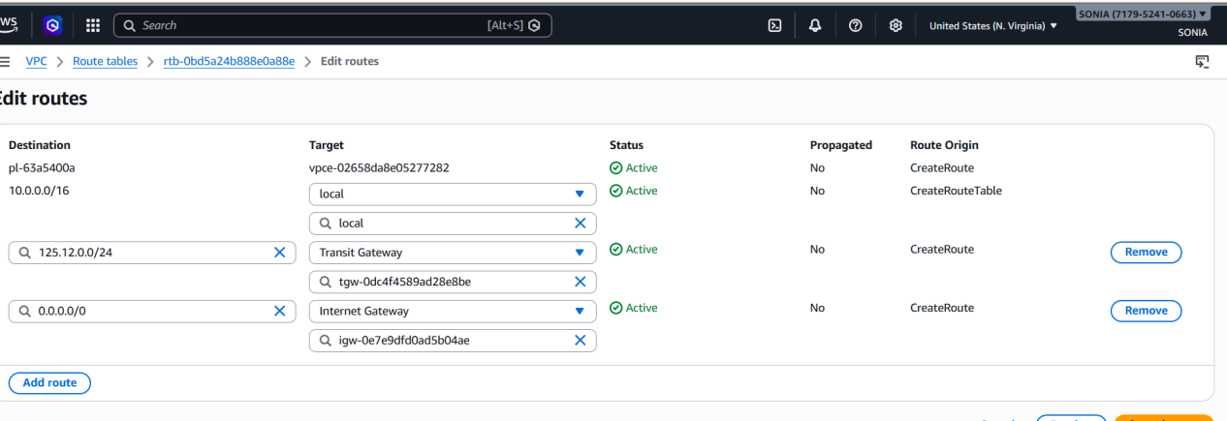
Then go to our account id and à select credentialsàselect access key pairàdownload.csv fileàgo to git bash and connect with the any instance
àaws configureàaccess key id shown in below
